**SPRINT-5**  
**1. Application Status Customization Story**  
  
As a user, I’d like to customize the statuses of applications for a job as per my requirement. Rearranging the order, renaming, adding and deleting the stages are the required functionalities in this.  
  
Acceptance Criteria:  
--> Once a user selects View applicants button from the All jobs page or from view full job details page, the user is taken to the Applicants page (existing functionality)   
--> The top ribbon itself should function as a slider such that a user should be able to slide the ribbon to view all the stages in it and should be able to select one of the stages if required. eg: multiple sheets in google sheets  
--> Which ever stage a recruiter selects, the data of that stage should be displayed  
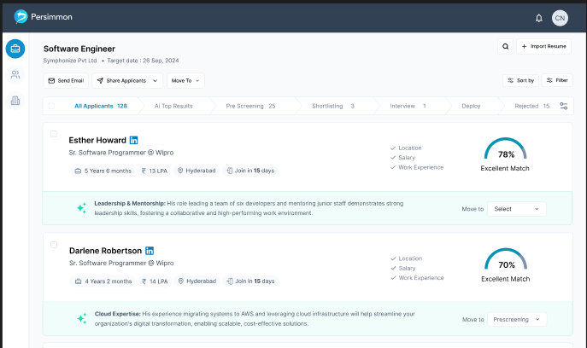  
--> Here, by default, the columns to be displayed are:  
i. All Applicants  
ii. AI Top Results (This is to be worked in the upcoming sprints)  
iii. Pre-Screened  
iv. Shortlisted  
v. Interviewing  
vi. Deployed  
vii. Rejected  
Followed by a Customization Icon.  
--> Once a user selects this icon, a side menu bar is to be displayed (from right side)   
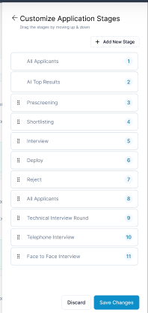  
  
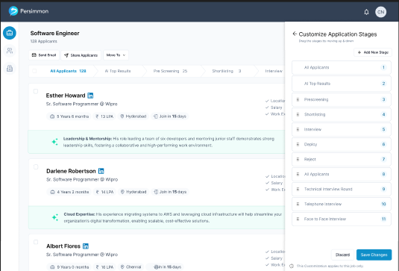--> The title of this menu should be “Customize Application Stages” followed by a sub-title “Drag the stages to move up or down”. This menu should consist of all the above columns as a list. Including these columns, the user should be provided with options such as  
i. Re-arranging,  
ii. Deleting,  
iii. Renaming,  
iv. Adding a new stage.  
v. Two CTAs as ‘Discard’ and ‘Save Changes’  
  
**Note**: Except for All Applicants and AI top results stages as these two stages are to be fixed and no modification should be allowed   
  
  
i. Re-arranging: Task  
--> To the left corner of every stage, a rearranging icon is to be provided for the user to move a stage up or down.   
--> The rearrangement should be applied for the Applicants list only after the user selects the “Save Changes” button at the bottom.  
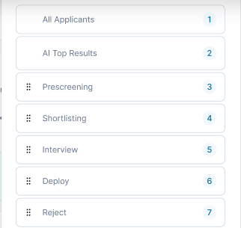  
--> A user can also press and hold to drag the stage up or down.  
  
--> Once a user saves the changes, the same sequence should be updated in the top ribbon as well as in the “Move to” button’s options, for that particular job only. (which means these changes are only for a particular job but not for all the jobs)  
  
ii. Deleting: Task  
--> If a user wants to delete any stage of the application status, they should be able to do that by hovering on that stage. Once hovered, two options are to be displayed at the right corner of that stage. One is to delete and the other is to edit the name of that stage.  
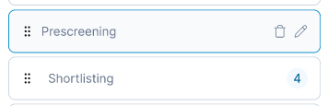  
--> If a user wishes to delete a stage, then after selecting delete icon, a pop-up should appear on screen for confirmation.  
--> This Pop-up should contain a title “Are you sure you want to delete?” followed by a sub-title “By deleting, you’ll lose the track of applicants data of this stage” and followed by two CTAs as  
1. Cancel (Secondary button) to cancel the deletion and should take the user to customization menu.  
2. Delete (Primary, in red colour) to delete the stage and should take the user to customization menu.  
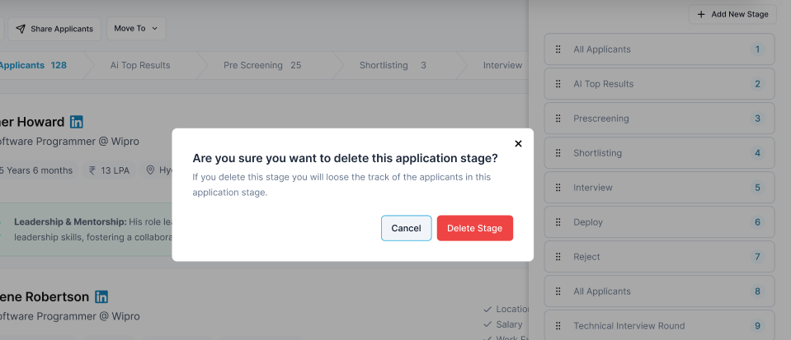  
  
--> Until the changes are saved, the modifications should only take place at the Customization menu.  
--> Once a user saves the changes, the same sequence should be updated in the top ribbon as well as in the “Move to” button’s options, for that particular job only. (which means these changes are only for a particular job but not for all the jobs)  
  
iii. Edit (Renaming) Task  
--> If a user wants to delete any stage of the application status, they should be able to do that by hovering on that stage. Once hovered, two options are to be displayed at the right corner of that stage. One is to delete and the other is to edit the name of that stage. also double clicking on that tab should enable edit mode.  
  
--> Once a user selects the Edit icon (pen icon) then the name of that stage should be editable  
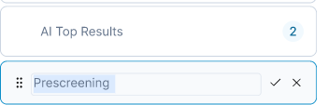  
If the user selects Tick mark, then the modified name should be displayed in the Menu bar. If the user selects cross mark, then the edit action should be cancelled, and earlier name (without changes) should be displayed in the Customization menu.  
--> If the name already exists then there should be an Error message thrown at the bottom of the menu (above the CTAs) stating “Stage already exists” with red font.  
--> This Name field should only accept 2 styles as ‘Only alphabets’ or ‘Alphabets + numeric values’. If the user enters any other value apart from the accepted format, then the error message to display should be, “Stage names can only be Alphabets or Alphanumeric values”.   
--> Apart from alphabets and numbers, only space and hyphen ‘-‘ should be accepted. However, the stage name should not start or end with a space or hyphen and nor should have two consecutive spaces or Hyphens. If the user wants to save the name with any unacceptable format, then the error message to display should be “Please enter a valid name”. If the user enters any special character apart from hyphen, then the error message should be “No special characters are allowed except for Hyphen.”  
--> Minimum value can be 3 and maximum can be 30 for the name of a stage.   
--> Until the changes are saved, the modifications should only take place at the Menu bar.  
--> Once a user saves the changes, the same sequence should be updated in the top ribbon as well as in the “Move to” button’s options, for that job only. (which means these changes are only for a particular job but not for all the jobs)  
  
iv. Adding a new stage: Task  
--> If a user wants to add a new stage, then should be able to do that by selecting the “add new stage” button (Primary) at the top of all the stages in the Customization menu.  
  
  
--> Once a user selects this button, a new stage should be added at the bottom of the stages list. By default, the place holder for this stage should be “Stage name-1” and the user should rename the stage to continue with their next action. Here, a user can either select tick mark or cross mark to save the new stage.  
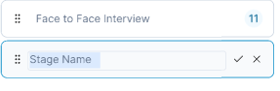  
--> Until the changes are saved, the modifications should only take place at the Menu bar.  
--> Once a user saves the changes, the same sequence should be updated in the top ribbon as well as in the “Move to” button’s options, for that job only. (which means these changes are only for a particular job but not for all the jobs)  
--> The maximum stages should be limited to 20 and post that, the Add stage button should be disabled.  
  
v. CTAs: Task  
--> If a user selects the “Discard” button, then all the recent changes before saving, should be discarded such that the recently saved stages should be displayed on the Customization menu.  
--> If the user selects “Save Changes” button, then all the changes made by the user should reflect in the Customization menu and the top ribbon and “Move to” button’s options.  
  
àAt the bottom of the CTAs, a sentence “This customization applies to this job only” is to be displayed.  
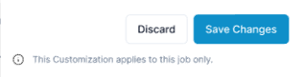  
  
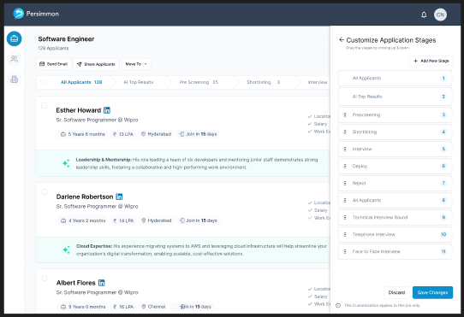

**2. Filters: EPIC**  
Description:  
As a recruiter, I’d like to filter the applicants list as per my requirements. To do that, I’d like to have dedicated filters for each category.   
  
2.1 Layout **Story**  
Acceptance Criteria:  
--> Once the user selects the filters icon from the All Applicants page or Applicants of any job page, the user should be taken to anew page where on the left side all the filter categories are displayed and filter setting on the right side should appear.  
--> The title of this page should be “Advanced Filters” followed by a sub-title “Modify your preferences to re-rank”.   
Note: These filters should work on both “and” and “or” basis.---SARATH  
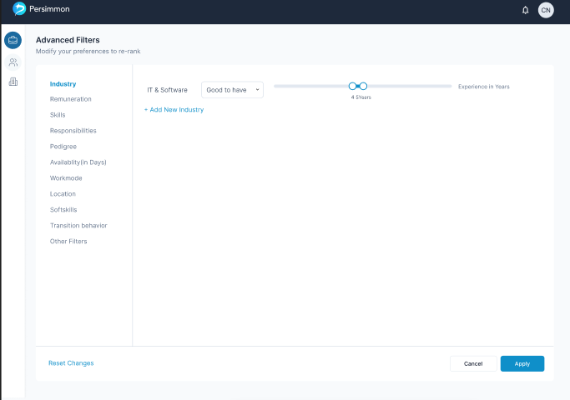  
  
2.1.1 Filter categories **TASK**  
--> The filter categories to display on the left side of the screen are:  
i. Industry type  
ii. Remuneration  
iii. Skills  
iv. Responsibilities  
v. Pedigree  
vi. Availability  
vii. Work mode  
viii. Location  
ix. Soft skills  
x. Transition behaviour  
xi. Other filters  
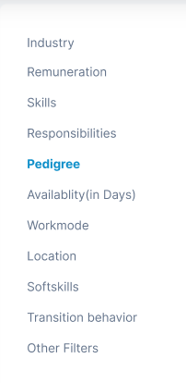  
  
  
2.1.2 Filters CTAs **TASK**  
--> At the bottom of this page, three CTAs should be included such as:  
i. **Reset changes**:  
-This is to be positioned at the bottom left of the screen as a Hyperlink button.  
- Once a user selects this, all the changes made by that user should be deleted such that default values of filters should be displayed on the screen. Even after selecting the button, the user should still stay at the filters page only (first stage of filters)  
ii. **Apply:**  
- This is to be positioned at the bottom right of the screen as a Primary button  
- Once a user selects this, all the changes made by that user should be applied to the data such that the filtered data should be displayed on the screen. Once the user selects this button, then the user should be taken to filtered data in the Applicants page automatically.  
- This filtered data should also consist of ranking (based on filters applied) to each applicant, in the AI top results Stage.  
- If the user hasn’t provided any required information in any of the filters, then the user should be taken to that filter’s screen with an error message at the bottom of apply button stating, “Please provide filter details”. If the user misses to fill on multiple screens, then the user should be taken to first filter in the left side list, followed by next.  
Ex: If the user has provided the preference but not the dropdown, then it’s an invalid data case to apply a filter.  
iii. **Cancel:**  
 - This is to be positioned at the bottom of the screen and to the left of Apply button and should be as a Secondary button  
- If a user selects this, all the changes made before applying should be removed. Which means the saved filters should reflect and all the unsaved filters should be discarded. If the user is cancelling from default values, then the default filters are to be displayed. Once the user selects this button, then the user should be taken to the Applicants page automatically.  
--> At the bottom of every category screen, 16px should be the gap left from the bottom edge of the screen.   
-->These filters are extracted from recruiter inputs, and dynamic weight for each recruiter, it's a backend thing, for now we need to keep this consideration – need to explain to developers  


2.2 Industry type **Story**  
**-->** Once a user clicks on Filters icon on All applicants' page or Applicants of a particular job, this should be the landing filter.

--> This should consist of:  
--> **Industry type** field as a Type a head with same functionality and features as Company details page  
--> **Preference** filed with a drop down consisting of 3 options as:  
i. Good to have  
ii. Preferred to have  
iii. Must have  
--> **A slider** with:  
1 to 20 with 1 breakpoint each. Post that, 5 per break point until 50-**Design to be updated soon**  
--> A text beside the Slide bar stating “Experience in Years”  
--> Also, an option to “Add New Industry” as a hyper link button (tertiary button)  
--> If a user selects this Add new industry button, then both fields and slider should appear with default values as (Industry type for Industry type field; Good to have for preference field; 4 as minimum and 5 as maximum for the slider).  
However, a user should navigate to both fields and slider, once added a new one.  
--> If a user selects an existing industry type, then a error message should display on screen below the field stating “Industry type already exists”  
--> Once a user modifies the industry type, then it should be unchangeable. (for the first industry type, it shouldn’t be editable at all  
--> A user can add upto 10 industries such that after 10 entries, the Add new industry button should be in inactive state (Disabled).  
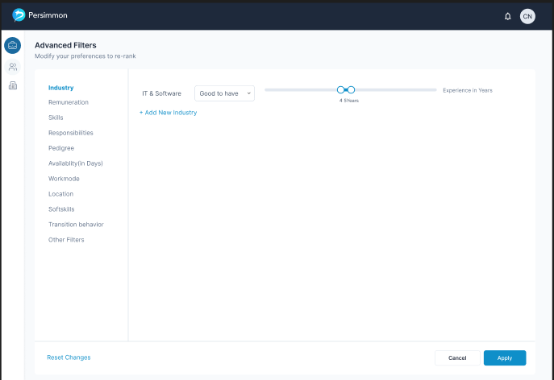

2.3 Remuneration **Story**  
--> If the user selects the filter “Remuneration” from the left menu, then the user should be able to see the below screen:  
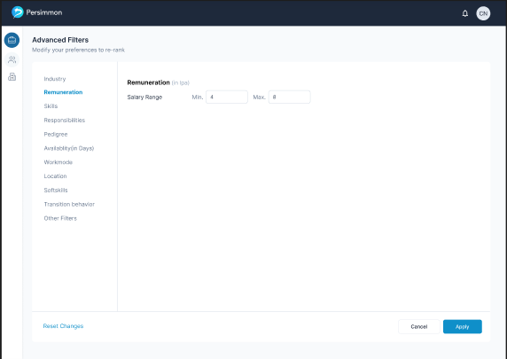  
--> This screen should consist of a title “CTC” followed by “(in LPA)”   
--> A text “Salary Range” should be included at the bottom of title, followed by 2 input fields as:  
i. Minimum salary as “Min.”   
(acceptance range: Minimum 1 Max 99)  
ii. Maximum salary as “Max.”  
(acceptance range: Min 2 Max 100)  
-Both these fields should only accept the numerical values and a full stop.  
-No other characters are allowed to display in these fields either. Which means, only the valid data should be visible, hence no error messages are required, except for the condition that Minimum salary should be less than Maximum salary.

2.4 Skills **Story**  
--> If the user selects the filter “Skills” from the left menu, then the user should be able to see the below screen:  
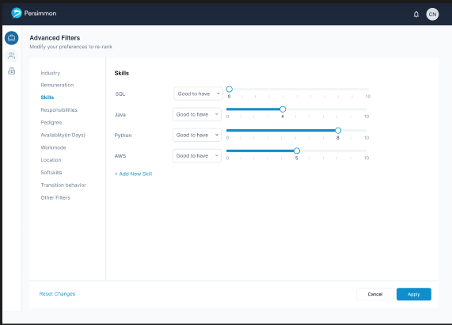  
--> Which ever skills the user has provided in the Job Description and also for the required skills section while creating a job post, those skills have to appear in this screen.  
--> This screen should consist of a title “Skills”  
--> Below the title, the name of the skill has to be included, followed by:  
i. **Preference** filed with a drop down consisting 3 options as:  
- Good to have  
- Preferred to have  
- Must to have  
ii. **A slider** with:  
0 to 10 with 1 breakpoint each.  
Here's how each break point should work (for backend):  
0 stands for Minimal to none knowledge on that skill for applicant.  
1 for Minimal  
2 Minimal to below average in basics of the skill  
3 average in basics of the skills  
4 Good in basics of the skill  
5 Excellent in Basics and minimal understanding in Advanced concepts  
6 Excellent in Basics and basic knowledge in Advanced concepts  
7 Excellent in Basics and Average knowledge in Advanced concepts  
8 Excellent in Basics and Above Average knowledge in Advanced concepts  
9 Excellent in Basics and good knowledge in Advanced concepts  
10 Excellent in both basics and advanced concepts of a skill  
**Note:** All these expertise details would be gathered during AI screening questions, while a job seeker applies for a job.  
--> By default, the values of each skill appeared (fetched from the JD), should consist which ever the user mentions.  
Ex: If the user has stated in JD that “Basic understanding in Java and Excellent knowledge in Python” then 4 for Java and 10 for Python should be the default values.  
--> A user should also be able to add a new skill by selecting “+Add new skill” button.  
--> If a user selects this “+Add new skill” button, then a text field should appear in the skill name field for the user to provide name of the skill with “Skill name” as place holder while, Preference filed and slider should appear with default values as (Good to have for preference field; 4 for the slider).  
However, a user should navigate to both field and slider, once added a new one.  
--> If the user enters any skill which isn’t available in the Skill set in the data base, then an error message should appear on screen stating “Please provide a valid skill”  
--> If the provided skill is already available in the list, then the error message to display below the field should be “Skill already exists”  
--> Once the user enters a valid name, then the skill name should be unchangeable.   
--> A user can add any number of entries too.  
  
2.5 Responsibilities **Story**  
--> If the user selects the filter “Responsibilities” from the left menu, then the user should be able to see the below screen:  
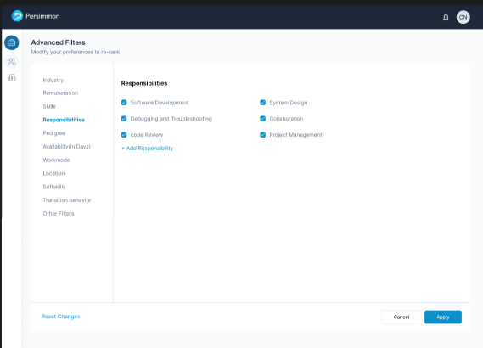  
--> Which ever Responsibilities the user has provided in the Job Description and while creating a job post, those Responsibilities have to appear in this screen.  
--> This screen should consist of a title “Responsibilities”  
--> Below the title, the name of the Responsibility has to be included, with a check-box.  
--> By default, all the check boxes should be checked as they’re mentioned in the JD. However, a user can check out any of the responsibilities if they wish to.  
--> A user should also be able to add a new responsibility by selecting “+Add new responsibility” button.  
--> If a user selects this button, then by default, the check box should be checked and a text field should appear to provide the responsibility name with a place holder “Responsibility name”.  
  
--> If the user enters any responsibility which isn’t available in the Responsibility set in the data base, then an error message should appear on screen stating “Please provide a valid responsibility”  
--> If the provided responsibility is already available in the list, then the error message to display below the field should be “responsibility already exists”  
--> Once the user enters a valid name, then the responsibility name should be unchangeable.   
--> A user can add any number of entries too.  
   
2.6 Pedigree **STORY**  
--> If the user selects the filter “Pedigree” from the left menu, then the user should be able to see the below screen:  
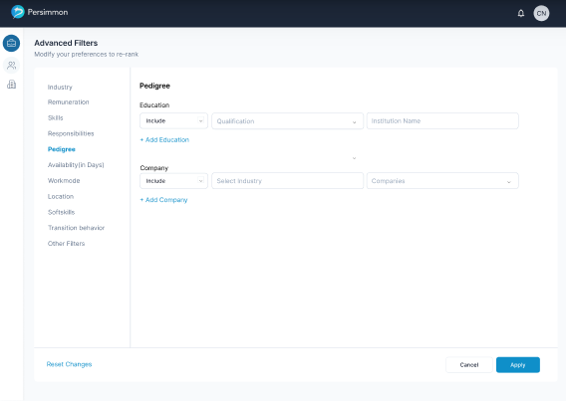  
--> The title of this filter should be Pedigree followed by two categories of filters as:  
i. **Education**:  
This filter should contain 3 fields:  
-The first one should be a drop down with two options as “Include” and “Exclude”  
If a user selects Include, the results should include the list of applicants under this. If the user selects exclude, then the list of applicants shouldn’t contain these specifications.  
-The second should be the Qualification drop down with “Qualification” as a place holder and a drop down as:  
Class 10  
Class 12  
Diploma  
Degree  
B.Tech  
M.Tech  
PhD  
Post Graduate  
**(TBC)**

**-**The third field should be the institution name with a type head functionality (Starting with logic only)  
List by Vyas  
--> A user can also add an education filed by selecting “Add Education” button.  
--> Once a user selects this, all the 3 fields should appear with Include and place holders as default values.  
--> A user can either provide only one filed (Qualification or Institution) or can even provide both.  
--> If the user provides an existing filter, then the error message to display below the field should be “Filter already exists”  
  
ii. Company:  
This filter should contain 3 fields:  
-The first one should be a drop down with two options as “Include” and “Exclude”  
If a user selects Include, the results should include the list of applicants under this. If the user selects exclude, then the list of applicants shouldn’t contain these specifications.  
-The second should be the Industry drop down with “Industry” as a place holder and a drop down of all the industries (just as industry type while creating a recruiters profile)  
**-**The third field should be the Company name with a type head functionality (Starting with logic only)  
List to be provided  
--> A user can also add an Company filed by selecting “Add Company” button.  
--> Once a user selects this, all the 3 fields should appear with Include and place holders as default values.  
--> A user can either provide only one filed (Industry or Company) or can even provide both.  
--> If the user provides an existing filter, then the error message to display below the field should be “Filter already exists”

2.7 Availability **STORY**  
--> If the user selects the filter “Availability” from the left menu, then the user should be able to see the below screen:  
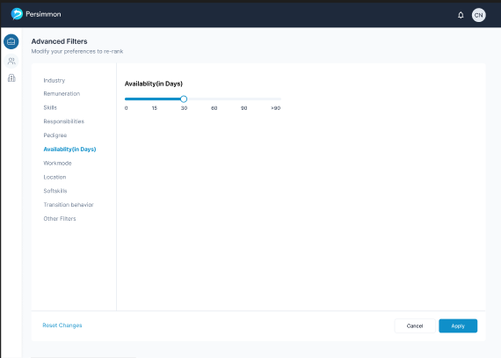  
--> The title of this filter’s page should be “Availability (in Days)  
--> Followed by a slider with 6 break points as:  
0, 15, 30, 60, 90, 90+  
--> The user can only select the maximum number while the minimum should be fixed at 0 (with no clickable to display)  
--> This should be fetched from the notice period data of the applicants, provided during the AI screening questions while applying for the job.  
  
2.8 Work mode **STORY**  
--> If the user selects the filter “Work mode” from the left menu, then the user should be able to see the below screen:  
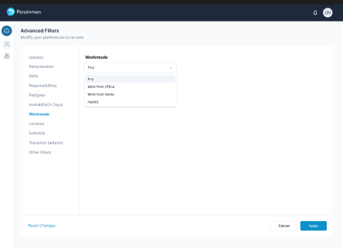  
--> The title of this filter’s page should be “Work mode” followed by a drop down field to select from:  
i. Any  
ii. Work from office  
iii. Work from home  
iv. Hybrid  
--> By default, Any should be selected.  
--> This data should be fetched from AI screening questions of an applicant while applying for the job. (notice period and also When can you join questions)  
  
2.9 Location **STORY**  
--> If the user selects the filter “Location” from the left menu, then the user should be able to see the below screen:  
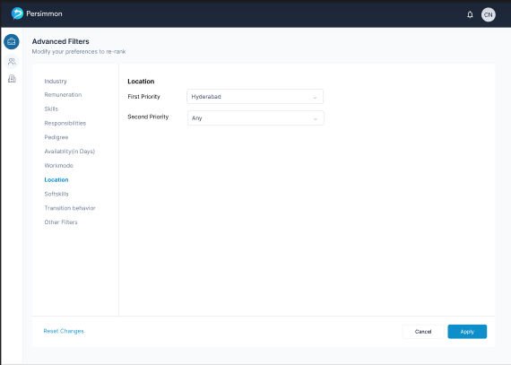  
--> The title of this page should be “Location” followed by:  
i. First priority (static text) and a location drop down with all the cities names (data same as job creation and an additional one “Any” on top of the list). By default, the value should be the job location provided by the user while creating the job post.  
ii. Second priority (static text) and a location drop down with all the cities names (data same as job creation and an additional one “Any” on top of the list). By default, the value should be Any.  
--> This data should be fetched from AI screening questions of an applicant while applying for the job. (What’s your preferred location/s? question)  
  
2.10 Soft skills **STORY**  
--> If the user selects the filter “Soft Skills” from the left menu, then the user should be able to see the below screen:  
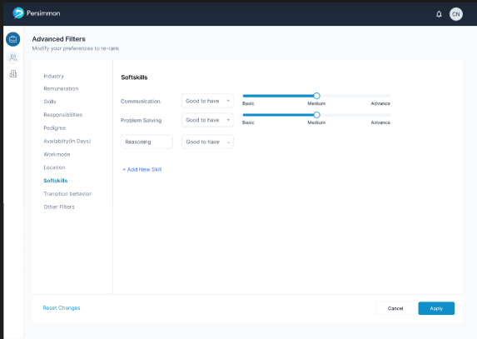  
Note: Ignore the Reasoning and it’s respective fields in the above image.  
  
--> Which ever Soft skills the user has provided in the Job Description while creating a job post, those skills have to appear in this screen.  
--> This screen should consist of a title “Soft skills”  
--> Below the title, the name of the skill has to be included, followed by:  
i. **Preference** filed with a drop down consisting 3 options as:  
- Good to have  
- Preferred to have  
- Must to have  
ii. **A slider** with:  
3 break points as “Basic”, “Medium”, “Advanced”  
**Note:** All these expertise details would be gathered during AI screening questions, while a job seeker applies for a job.  
--> By default, the values of each skill appeared (fetched from the JD), should consist whichever the user mentions.  
Ex: If the user has stated in JD that “Good communication skills with excellent problem solving skills”,  
Then the value for Communication skills should be medium while Problem solving should be Advanced  
--> A user should also be able to add a new Soft skill by selecting “+Add new Soft skill” button.  
--> If a user selects this button, then a text field should appear in the Soft skill name field for the user to provide name of the skill with “Soft skill name” as place holder while, Preference filed and slider should appear with default values as (Good to have for preference field; medium for the slider).  
However, a user should navigate to both field and slider, once added a new one.  
--> If the user enters any skill which isn’t available in the Skill set in the data base, then an error message should appear on screen stating “Please provide a valid skill”  
--> If the provided Soft skill is already available in the list, then the error message to display below the field should be “Soft skill already exists”  
--> Once the user enters a valid name, then the Soft skill name should be unchangeable.   
--> A user can add any number of entries hence no restrictions on the maximum limit  
  
2.11 Transition Behaviour **STORY**  
--> If the user selects the filter “Transition Behaviour” from the left menu, then the user should be able to see the below screen  
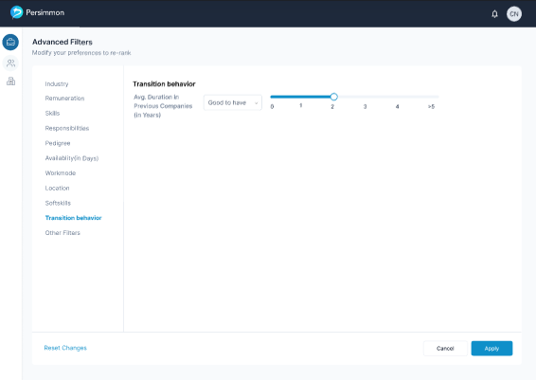  
(Note: The position of 1 in the slider should match with the other breakpoints)  
--> The title of this Filter’s page should be “Transition Behaviour”   
--> Followed by “Avg. Duration in previous companies (in Years)” and :  
i. **Preference** filed with a drop down consisting 3 options as:  
- Good to have  
- Preferred to have  
- Must to have  
ii. **Slider** with 6 break points as:  
0, 1, 2, 3, 4, +5  
--> The user can only select the maximum number while the minimum should be fixed at 0 (with no clickable to display)  
--> This transition should be fetched from an applicant’s resume and also from the AI screening questions.  
  
2.12 Other Filters **STORY**  
--> If the user selects the filter “Other Filters” from the left menu, then the user should be able to see the below screen  
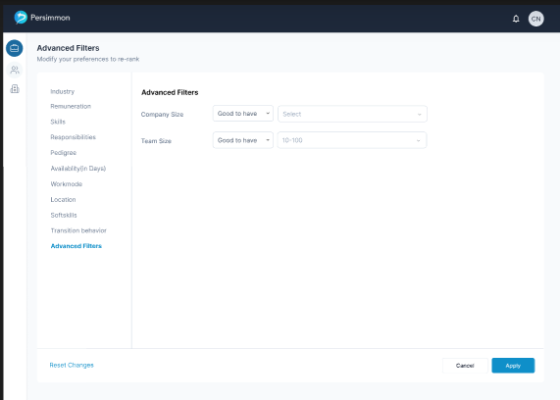  
  
--> The title of this page should be “Other filters”  
--> In this page, 2 filters are to be provided for the user:  
i. Company size (Static text) followed by preference field and company size dropdown with “Select” as a place holder. (the drop down includes the same data as for the recruiter’s profile creation).  
ii. Team size (Static text) followed by preference field and Team size dropdown with “Select” as a place holder. (the drop down includes the same data as for the Job creation).  
--> This **Preference** filed with a drop down consisting 3 options as:  
- Good to have  
- Preferred to have  
- Must to have  
--> A user can either provide 1 or both the filters to get the results.  
--> These details of an applicant are to be fetched from the AI screening questions while applying for a job and also from the resume, if available.  
  
  
3. Sign-Up (Modification) **TASK**  
--> Once a user successfully creates a password after signing up for the application, then, the user should be taken to the landing page (The screen that appears after logging in).  
--> This means that the user shouldn’t see the log-in page at all after successful password creation.  
  
4. Job Creation page, stage-3 (mod) **TASK**  
--> Beside the posting for client toggle switch, an “*i*” icon is to be included which, on hover should provide a sentence stating “Client’s information is used solely for matchmaking logic, not for posting”  
--> This icon should be available even if the toggle switch is On/Off. Which means a static icon.  
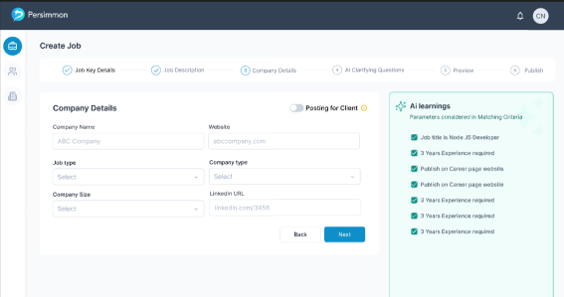  
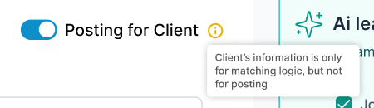  
The above is the reference on how the text should appear when hovered.  
  
  
5. Job Creation page, stage-4 (mod) **TASK**  
--> Beside the AI Clarification Questions title, an “i” icon is to be included which, on hover should provide a sentence stating “These questions are solely for accurate matching algorithms, not for posting”  
  
  
  
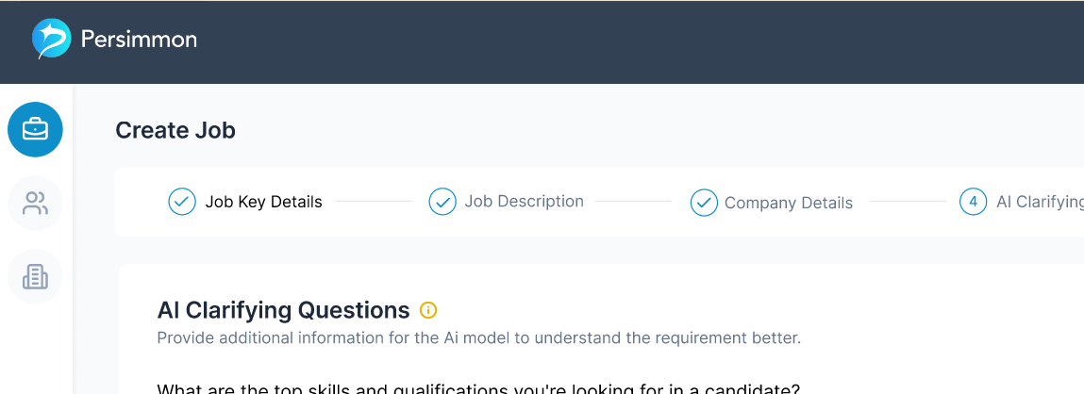  
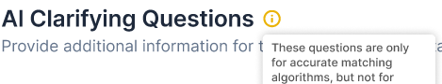  
  
(The above is the reference on how the text should appear when hovered.)  
  
  
6. Entire Type a head fields modification: **TASK**  
--> All the fields in the application with type a head functionality should only display the result with “Starts with” logic instead of “Contains”  
EX: If a user enters “A” then the results should only start with A but not any other letter.  
  
7. All jobs page (Mod) **TASK**  
--> For every column, a sort button (Up arrow and a down arrow) is to be provided for the user, as shown below:  
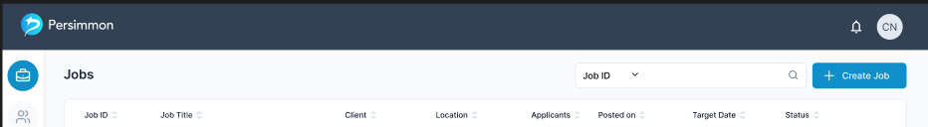  
  
--> If a user clicks once, it should be arrange the selected column’s data in ascending order, if the user selects again, then it should be Descending order and for the third time, it should reset the data to default.  
--> For status column, Ascending means “Active” jobs sorted according to ascending order of Job ID, then the Inactive jobs according to Job ID.,  
--> Descending means Inactive jobs first and then Active jobs in ascending order of job ID.  
  
à Also, in the search field’s drop down, the “Target date” should also be included.  
à Wherever the user selects in a row, the user should be taken to View full job details page. Except for the More Icon and Applicants column (including Eye icon).  
  
8. All jobs page, Inactive jobs (Mod) **TASK**  
àFor Inactive jobs, if a user selects more icon, then that should open a menu consisting only one option as “Edit & Repost”.  
à If a user selects this option, then the user should be taken Job creation page, Stage-1 with all the earlier details prefilled.  
à However, at the final stage (Publish) the button “Publish” should be replaced with “Publish as New”.  
à If a user selects this button, then a new job with a new unique Job ID should be created & posted, with ‘0’ earlier applicant data.  
Which means, if the closed job has 200 applicants, then that data shouldn’t get reflected in the newly edited and posted job.  
  
9. Applicant’s page (Mod) **TASK**  
à The existing Applicant’s page should contain a Back icon to the left of the job title.  
à Once a user selects this, then they should be taken to View job page.  
à If a user wants to go to All jobs page, (even if the user enters from All jobs to view applicants) then they should select the All Jobs icon in the left menu bar  
  
10. Import Resumes **TASK**  
--> Once a user selects the “Import resumes” button, then the below window should appear:  
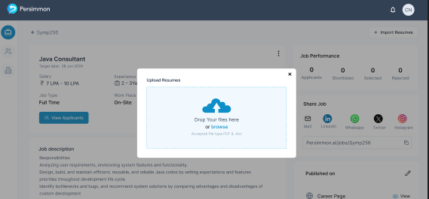  
--> This screen should contain a Cross (X) icon to cancel the action. Hence, a user cannot close it unless they select the cross icon.  
--> The text inside this window includes “Drop your files here or Browse”. Here Browse should be a hyperlink to open their local files.  
--> Followed by “Accepted file types: **PDF & .doc**”  
--> If a user selects any other file types apart from PDF and .doc, then an error message should display on the screen stating “Only PDF & .doc are accepted”  
--> After a user selects the valid files, then the upload window should appear as:  
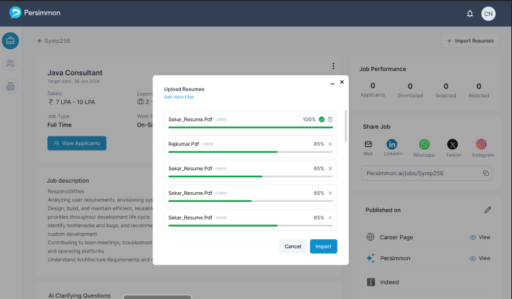  
--> In this screen, all the files are uploaded by that user at that time are to be displayed (only file names), followed by percentage of upload status and a cross icon (upon selection, that file should be removed from the list)  
--> Once the upload is completed, then the Upload status should be 100% followed by a Green Tick mark and a Delete option.  
If a user selects this Delete button, a confirmation window should appear with two CTA’s as  
“Are you sure you want to delete?” followed by   
i. Cancel (secondary button) to cancel the action  
ii. Delete (primary button) to delete the selected file. Once deleted, then that file should be removed from the list.  
--> Only 5 file names are to be displayed while a scroll bar should be provided for the user to check the other files.  
--> Below the files, two CTAs are to be included as:  
i. Cancel (secondary button) to cancel the action, which should open a confirmation window with:  
“Are you sure you want to cancel?” followed by   
i. No (secondary button) to cancel the action  
ii. Yes (primary button) to terminate the importing action completely  
ii. Import (Primary button) to import all the files into the application.  
--> On top of this window, two buttons are also to be provided as:  
i. Minimize (to minimize the screen)  
On minimizing:   
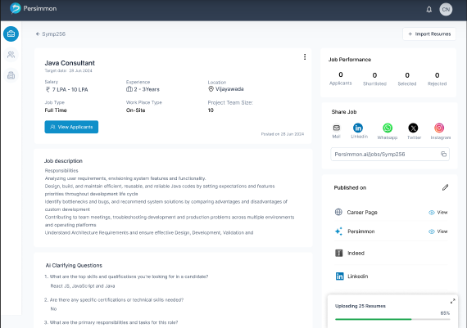  
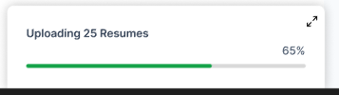  
Once a user minimizes the import resumes screen, then the above screen should appear, which should contain the number of files selected by the user as “Uploading *number of files* resumes”, progress of Upload status and Maximize button. If the user selects the Maximize button, then the Uploading window should appear.  
However, once the Upload status is 100%, the then the Count text should become “Uploaded *number of files* resumes” followed by a green tick mark. To import the uploaded resumes, the user Should select the Import button. Hence, even if the user is in Minimized screen, to complete the importing process, they should click on Maximize button and then Import button.  
  
ii. Cross (X) icon, to cancel the import resumes action, which should open a confirmation window with:  
“Are you sure you want to cancel?” followed by   
i. No (secondary button) to cancel the action  
ii. Yes (primary button) to terminate the importing action completely.  
  
--> Once all the uploaded files are imported, then Import resumes window should disappear and the count of applicants should change accordingly.  
  
11. Share job card: Meta Open graph integration **TASK**  
--> Whenever a user shares the job, it must be shared in the Meta open graph format  
EX:   
--> The text to use and the image will be shared before we start with the sprint.  
  
12. Skeleton loaders (Global) **TASK**  
--> For all the pages in the application, whenever the page (UI) is loading, the skeletal part of the page should appear on the screen.  
Ex: Instagram reels/posts while having slow internet.  
Ref. images would be shared before starting with the sprint.  
  
13. LinkedIn SSO in Signup and Login Pages: **TASK**  
--> The sign up and log in pages should consist of a static text: ”or continue with” followed by ”LinkedIn” button.  
--> Once a user selects this while during the sign-up process, the user should be taken to LinkedIn log in page. After successful log-in into LinkedIn, the user should be redirected to Recruiter details page where the user must provide their details.  
--> All the details fetched from the LinkedIn should be noneditable.  
Ex: Name, LinkedIn URL, email ID  
--> If the user already logged in into their LinkedIn, the on selecting the LinkedIn button, the details should be fetched directly, and the user should be taken to fill details page.  
--> If the user is logging into application using ”LinkedIn” button, then the same process should happen (except for the landing page, as the landing page for a user who filled their details should be All jobs page)  
  
